Sports and holistic health care and children living with HIV/AIDS

Snehagram

Executive Summary
Snehagram, an institution located in Nachikuppam in Krishnagiri district in Tamil Nadu is a vocational training and rehabilitation center for adolescent children living with HIV who are mentored to transition into healthy and professionally productive adults in the future. It is the learning site of the USAID Orphans and Vulnerable Children (OVC) Social Protection Project and an initiative of Camillians India under the Sneha Charitable Trust and employs the use of sports, yoga, physical activity and holistic health care to instil positive way of living among children living with HIV and creating resilience in them. From sports training and participation in championships, to a daily dose of yoga, running and physical activity involving gardening, maintaining cleanliness in the campus, organic farming and dairy farming, the children are exposed to a regime which keeps them busy, fit, confident and positive. The nutritious food, high quality medical care, effective management of opportunistic infections coupled with attentive counseling support to ensure psychosocial health is a unique approach that aims for the overall growth and development of children living with HIV/AIDS.
The institution is headed by Father Mathew Perumpil who is the Director of Snehagram. Phone- 09448058060 and e-mail: mperumpil@yahoo.com.
Background
Adolescents, defined by United Nations as those between 10-19 years, are children mostly protected under the Convention on the Rights of the Child yet have vulnerabilities and needs that often remain unaddressed (Progress of Children: a report card on adolescents, 2012) like death due to violence, suicide, road traffic injuries, complications of pregnancy or child birth; teen pregnancy; high school drop-out rates and illiteracy; sexual and domestic violence. Neither children nor adults, adolescents lack the services that respond to their distinctive needs. Interventions for children very often focus on the younger ages and adolescents ‘age out’ of pediatric health care. Many adolescents are excluded from programs and services for adults like the services that would reduce their risk of HIV and STIs or prevention of unwanted pregnancies because of laws that limit access to these without parental consent. The adolescents who are living with HIV have additional vulnerabilities that come with stigma and discrimination around their status, orphanhood if they have lost one/both parents to HIV/AIDS, lack of care, health concerns, insecurity over the future, child-headed homes, and low self- esteem. Adolescents constitute an increasing percentage of new HIV infections in both developed and developing countries requiring a wide range of expertise to ensure primary medical, health and case management services. But a glance at the HIV programs around the world reveals there is no scientific data of what happens to these adolescent children living with HIV and no clear strategies and programs that focuses on the future of these children.
There was a need felt to address the issues of adolescents living with HIV/AIDS by Sneha Charitable Trust(SCT) which had experience of caring for younger children living with HIV at the Sneha Care Home in Sarjapur, Bangalore. The concept of Snehagram, an institution that would take in adolescents from Sneha Care Home, other institutions and community in their focused on developing the vocational and life skills to prepare them to become economically independent and be able to tackle any different obstacles in life efficiently.
Intervention
Life in this 17- acre ecology friendly, green and luscious campus is bustling with activities from the crack of dawn where children have a daily exercise routine which starts with morning yoga and running and in the afternoons they play games or train for athletic competitions. The sports that are played include football, basketball, throw ball and cricket. Sports occupies a central place among all their other activities and plays a significant role in maintaining not just physical health, fitness levels among the adolescents living with HIV but also ensures attaining mental health. The children are motivated to excel in whatever activity they are engaged which causes them to be mindful of how they care for their own bodies.
Children in Snehagram receive professional training and mentoring from Bangalore School Sports Foundation (BSSF) to prepare them to compete in annual sporting events for children held at different levels. There are also running volunteers who give hand-holding support to children who want to run marathons. Children train and prepare to participate in several sporting events like Champion in Me, Auroville Marathon, Kaveri Trail Marathon, Bangalore Wellness Run and the TCS Run to name a few. With each passing season, these children are improving their sporting skills and performances and along with it, breaking district, state and national records.
  - Other physical activities organized to keep children engaged and develop qualities of hard work, discipline, timeliness, management of duties, team work and focus include maintaining cleanliness in the hostels, kitchen, school campus, administration office, the compound and the gardens. Children follow a roster to carry out their different roles around the campus. The organic farming and dairy farming are led by children providing not just nutritious vegetables and fruits for their consumption and for sale but are honing farming and entrepreneurial skills in them. All these outdoor activities are exposing children to fresh air, clean environment and team work and making children fit, interactive and confident. The children are provided well balanced nutritious food and good medical care.
Successes
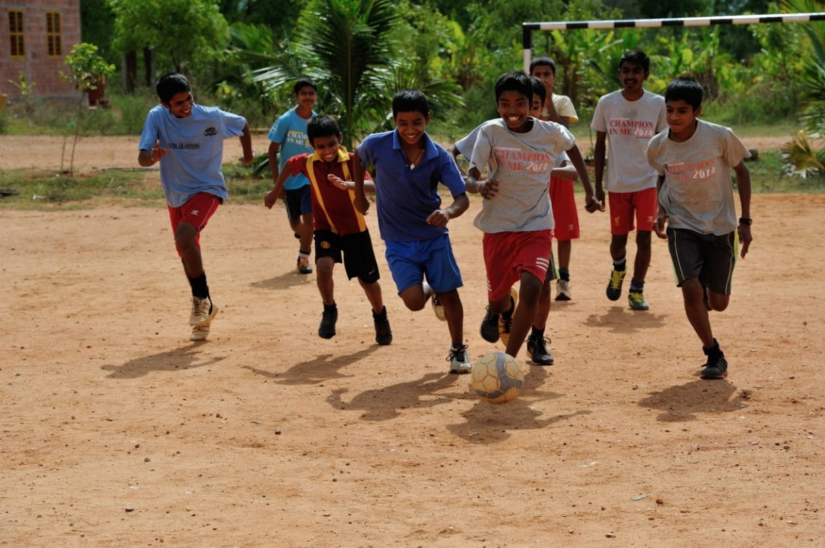
Figure 1Sports- a core program in Snehagram
Most of the children living in Snehagram from different age groups and gender assign the improvement in their health on the physical activity, sports and yoga they practice on a daily basis. There are accounts where children who frequented hospitals often, were very sickly with low stamina for going about daily activities after taking up running and other sports have found remarked improvement in their stamina levels, reduced incidence of falling sick and depression and attainment of positive energy. There are children who used to be loners and shy battling with emotional issues of neglect or abandonment but who after taking up outdoor activities, games and sports are capable of managing their emotional upheavals constructively and direct it to aim to improve their game and sporting performances. A girl who used to have trust issues when she first came to Snehagram has transitioned into a confident and friendly girl after she took up running. From the interviews conducted with all the children living in Snehagram, majority of the children believe sports and their outdoor physical activities have done them good and rely on it as a solution to overcoming sickness. The rate of participation in sporting activities is very high in the institution. The successes are many and evidence of sporting excellence in Snehagram comes in the form of the many trophies displayed in the multi-purpose hall in the dining area. The effect of sports and physical activity on the overall health of children in Snehagram are narrated by the nurse, the counselor and the staff who have been the witness of the change.
The biggest success story of sports and health of adolescents living with HIV is of Babu Seenappa and Manik Prabhu, two children who joined the institution in 2014 with complaints like constant fever and body pain and were introverts who have reached excellence in sports at the international level, representing India at the International Children’s Games at Alkmaar in Netherlands in 2015 in 1500 m and 100 m race. They now enjoy good health, positive attitude, confidence and exhibit leadership qualities. They are recognized as exemplary achievers who overcame the obstacles characteristic to children living with HIV to brush shoulders with others and excel.
Challenges
One of the biggest challenges for an institution to carry out a program on sports, yoga and physical activity is the financial resources needed to employ professional coach, physical therapist, nutritionist and staff to supervise their health, nutrition, participation etc. and the investment in terms of infrastructure required, transportation for facilitating children to participate in different sports events in the district, national, even international level. There is no sponsorship available for conducting studies like these to explore the effect of sports and physical activity on the health of CLHIVs.
Conclusion
There are no studies that focus on the correlation between sports and physical activity with HIV/AIDS and immunity among children who are infected but the several case study and testimonies of adolescent children at Snehagram excelling in sports is a compelling story and persuasive evidence. How else can you explain a child living with HIV/AIDS running a 10 kilometer run during ‘Champion in Me’( an annual sports events held for CLHIVs in Karnataka) if not for the enhanced immune system and improved health?
Sports, by itself, cannot effectively address HIV and AIDS and a sports- based initiative should not be a stand-alone but integrated with other prevention strategies. Snehagram is a good model of how sports and comprehensive health management program can improve the lives of adolescent children living with HIV/AIDS.
Note: This study requires more in depth research and analysis on children’s health.

